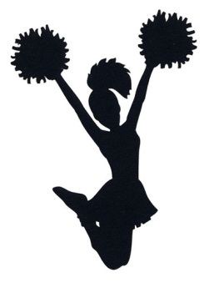
January 2018
Sunday | Monday | Tuesday | Wednesday | Thursday | Friday | Saturday
 | 1 | 2 | 3 | 4 | 5 | 6
 | No School | Practice 3-4pm | Boys BB vs. Stratford | (Wrestling Match in Gym)
7 | 8 | 9 | 10 | 11 | 12 | 13
 |  | Girls BB vs. Bellmawr | Practice 3-4pm | Practice 3-4pm
14 | 15 No School | 16 | 17 | 18 | 19 | 20
 |  | Practice 3-4pm | Boys BB vs. Barrington | Practice 3-4pm
21 | 22 | 23 | 24 | 25 | 26 | 27
 |  | Practice 3-4pm | Boys BB vs. Brooklawn | Girls BB vs. Brooklawn
28 | 29 | 30 | 31
 | Practice 3-4pm | X:Flex Option  (Wrestling Match in Gym) | Girls BB vs. Runnemede

