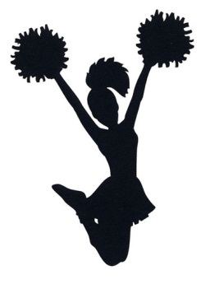
December 2017
Sunday | Monday | Tuesday | Wednesday | Thursday | Friday | Saturday
 |  |  |  |  | 1 | 2
3 | 4 | 5 | 6 | 7 | 8 | 9
 |  | Practice 3-4pm | Practice 3-4pm | Practice 3-4pm
10 | 11 | 12 | 13 | 14 | 15 | 16
 |  | Practice 3-4pm | Practice 3-4pm | Practice 3-4pm
17 | 18 | 19 | 20 | 21 | 22 ½ Day | 23
 |  | Girls BB vs. Gibbsboro  (wrestling in gym) | Practice 3-4pm | Boys’ BB vs. Runnemede
24 | 25 No School | 26 No School | 27 No School | 28 No School | 29 No School | 30
31

